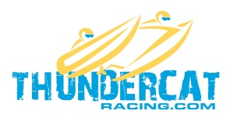
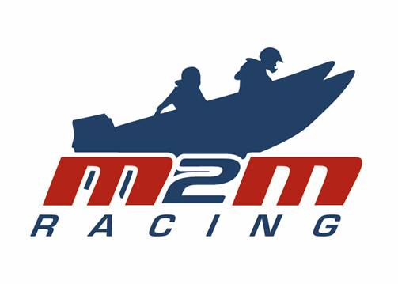

RACE ENTRY FORM 2020 P750 THUNDERCAT CHAMPIONSHIP
ORGANISED BY M2M RACING CLUB

PLEASE COMPLETE THIS FORM LEGIBLY IN BLOCK CAPITALS

COMPETITOR (Driver) | Licence No: | DOB:
Name: | Club: M2M Racing Club Limited
Address: | Tel. No. Home:
 | Tel. No. Work:
 | Tel. No. Mobile:
Post Code: | Email:
Medical History | Blood Group if known:
State blood group if known and any medical abnormalities that should be known in an emergency; i.e.: Allergies, transfusion reaction etc. (if none, state none) *Also declare any regular medication
Competitor Next Of Kin (I.C.E) | NOK Name:
Address: | Tel (home):
 | Tel (Work):
 | Tel (Mobile):
Postcode: | Email:
COMPETITOR (Co-Driver) | Licence No: | DOB:
Name: | Club: M2M Racing Club Limited
Address: | Tel. No. Home:
 | Tel. No. Work:
 | Fax No. Mobile:
Post Code: | Email:
Medical History | Blood Group if known:
State blood group if known and any medical abnormalities that should be known in an emergency; i.e.: Allergies, transfusion reaction etc. (if none, state none)*Also declare any regular medication
Competitor Next Of Kin (I.C.E) | NOK Name:
Address: | Tel (home):
 | Tel (Work):
 | Tel (Mobile):
Postcode: | Email:
BOAT | Class: P750 Pro-Stock ___ or Modified ___
Name of Boat: | Make of Hull:
Race No: | Sponsors:
Hull Reg. No: | Boat Colour:
Engine number: | Make of engine/cc/hp:

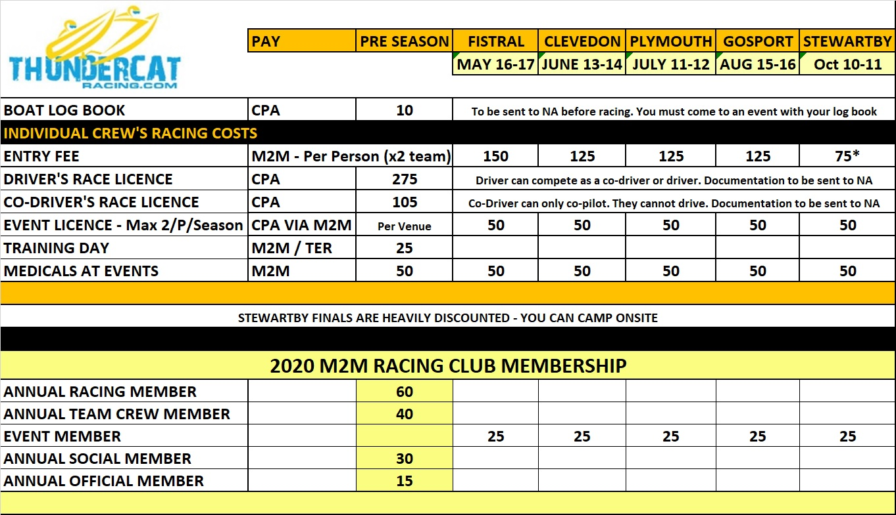

Please return this form duly completed asap - latest by 20th March 2020.
1 month prior to the event - a deposit of £100 of the entry fee must be paid
2 weeks prior payment of balance of entry fee
20% surcharge if paying entry fee on the day. ALL ENTRY FEES ARE NON-REFUNDABLE
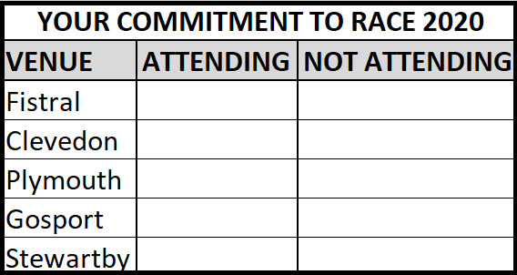

Email to: Shirley.nellthorpe@gmail.com

Payments to M2M Racing Club Limited
Account Name: M2M Racing Club
Sort Code: 20-79-25
Account No: 80498564

THIS DOCUMENT IS TO CONFIRM COMMITMENT AND ACKNOWLEDGING THAT THE TEAM WILL ABIDE BY THE RULES THAT THE SERIES WILL RUN BY FOR THE 2020 THUNDERCAT CHAMPIONSHIP AND M2M RACING CLUB OR ASSOCIATES WHO ARE HOSTING EVENTS FOR THE THUNDERCAT RACING COMMUNITY.

RISK STATEMENT

Powerboat Racing is by its nature a dangerous sport and therefore inherently involves an element of risk. However, I understand that having good knowledge of the rules and ensuring that my equipment is in good working order will help to minimise risks. By participating in or becoming involved with Powerboat Racing organised by BPBA affiliated clubs either as a participant, team member or otherwise individuals agree and acknowledge that:

- they are aware of the inherent risk involved in the sport and accept responsibility for exposing themselves to such inherent risk, including risks to their person, their property, drowning, hypothermia, collision injuries burns and other physical injuries as well as possible death
- they have satisfied themselves that they have the necessary skill and knowledge to take part in the event and deal with the conditions that may arise in the course of a race
- they will not participate in the event whilst under the undue influence of alcohol, drugs or whilst otherwise unfit to participate
- they are responsible for the safety of themselves their crew their boat and their property whether afloat or ashore and that the management of their boat including insurance is solely their responsibility
- scrutineering does not constitute a condition survey of the boat and it is solely their responsibility to decide whether or not to start or to continue in any powerboat race
- ensuring the efficiency and suitability of the helmets and racing vests worn is solely their responsibility
- the provision of a race management team, patrol boats and other volunteers by the event organisers does not relieve them of their responsibilities
- the provision of patrol boat cover is limited to such assistance particularly in extreme weather conditions as can be practically provided in the circumstances
- to be bound by the conditions of the Race Entry Form, Racing Instructions / Advance Programmes and the General Competition Rules of the UIM and the BPBA-CPA
- they will accept the decisions of the organising committee and officials nominated by the organising committee.
- they understand that is their responsibility to ensure that the event has suitable insurance cover in place before participating and it is also their responsibility to ensure that they familiarise themselves with event Risk Assessments & Race Instructions / Advance Programmes and bulletins before participating.
INDEMNITY
Participants in the event will be required on signing on to the event to save harmless and keep indemnified:
(a) The owners of the premises at which the event is held;
(b) The organising club, the sponsors and the BPBA and their respective officials, servants and agents; and,
(c) The other boat owners, drivers, passengers or mechanics engaged in the meeting (together with the “Indemnified Parties”) AGAINST all actions, claims, costs, expenses and demands in respect of loss of or damage to the property of or personal injury sustained to the Indemnified Parties to the extent caused by the participants, their crew, their boat, their mechanics, support team, representatives or agents.

IMPORTANT NOTE: Persons under the age of 18 must have written authority signed by either Parent or Guardian.
THE RESPONSIBILITY FOR A TEAM’S DECISION TO PARTICIPATE IN A RACE OR TO CONTINUE RACING IS THEIRS ALONE
Competitor (Driver)

Signed………………………………Name……………………………………………..Date………………
PARENT/GUARDIAN (Driver if applicable)
Persons under 18 must have written authority signed by either parent or guardian

Signed………………………………Name……………………………………………...Date………………
Competitor (Co-Driver)

Signed………………………………Name……………………………………………..Date……………….
PARENT/GUARDIAN (Co-Driver if applicable)
Persons under 18 must have written authority signed by either parent or guardian

Signed………………………………Name……………………………………………..Date……………….

Please note that the rules are as per P750 - BPBA CPA including the 2020 ThunderCat appendix - UIM P750 for international competition.

